Modelling Report on the Spread of Fire in a Forest

# Overview

Based on the premise that a given piece of land — say a forest, comprising of burning trees, free areas and trees that are not burning, this report seeks to outline the procedures taken to model the spread of fire from a burning tree at a specific location to other trees across the forest. To model this, being a cellular automation simulation, the forest site was represented by a two dimensional grid of cells (Shiflet & Shiflet, 2006), each of which have a single state. Each state could indicate the existence of a tree, burning tree or free area in the forest and are represented as 0, 1, or 2 respectively in the two-dimensional array. Additionally, an evaluation would was carried out to determine the runtime difference in executing the models normally and parallelizing it.

# Implementation Methods

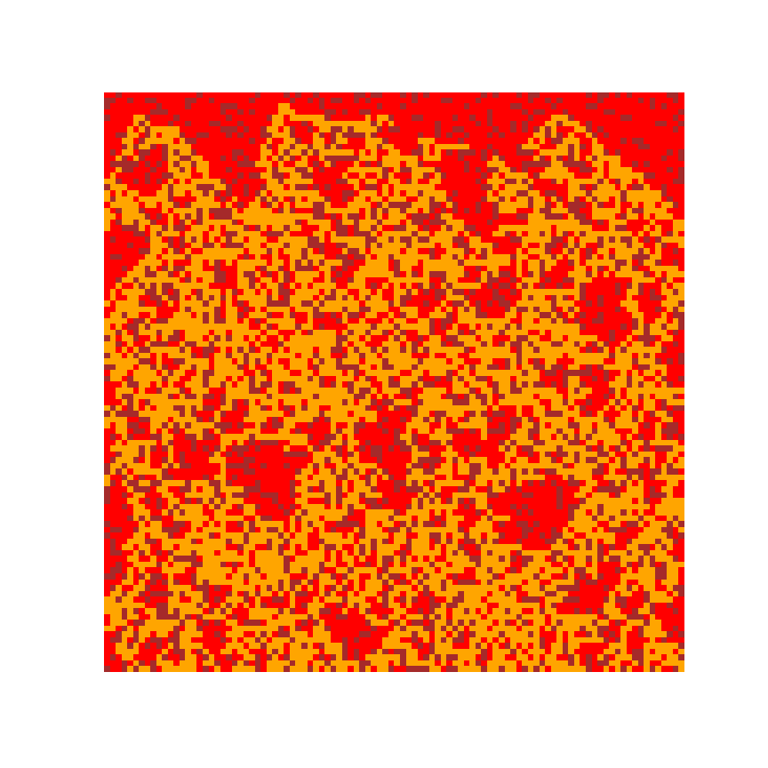

# Evaluation and Results

|  |  |  |
| --- | --- | --- |
| Forest Grid Size | Sequential | Parallel |
| 100 X 100 | 0.053 | 0.044 |
| 400 X 400 | 0.833 | 0.714 |
| 800 X 800 | 2.779 | 2.109 |
| 1000 X 1000 | 4.199 | 3.237 |
| 1200 X 1200 | 5.887 | 4.017 |
| 2000 X 2000 | 16.658 | 14.703 |

# Concluding Recommendations

# Bibliography

Shiflet, A. B. & Shiflet, G. W. (2006) *Introduction to computational science: Modeling and simulation for the sciences*. Princeton; Oxford: Princeton University Press.